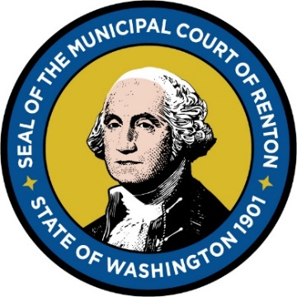

RENTON MUNICIPAL COURT
1055 South Grady Way, Renton, WA 98057
Court Telephone Number: 425-430-6550 Court E-Mail: rmcourt@rentonwa.gov

DECLARATION OF INABILITY TO PAY FINE & REQUEST FOR PAYMENT PLAN

Complete this form if you are asking the Judge to give you time to pay your fine(s) on the ticket(s) noted below. Sign and date the form once completed and submit to the Court by U.S. mail or E-mail to the addresses noted above. The Judge will review your request and you will receive written notice of the Court’s decision by mail and/or email.

Name:
Address:
Ticket Number(s):

- I admit that I am responsible for committing the violation(s) but I do not have the current ability to pay the fine(s) in full.

- I am asking the Judge to:

☐ Reduce my fine(s). ☐ Set up a payment plan.

- I receive state or federal public benefits, including, but not limited to: Temporary Assistance for Needy Families (TANF), Supplemental Social Security Income (SSI), medical care services under RCW 74.09.035, Medicaid, pregnant women assistance benefits, poverty-related veterans' benefits, food stamps or food stamp benefits transferred electronically, or refugee resettlement benefits.
☐ Yes ☐ No

- Are you currently employed?

☐ Yes ☐ No

  - If you are employed, please check the box below that accurately describes the number of people in your household that you support and the level of income you receive before taxes:
☐ | I have no dependents and my yearly income is less than $13,590.
☐ | I have 1 dependent and my yearly income is less than $18,310.
☐ | I have 2 dependents and my yearly income is less than $23,030.
☐ | I have 3 dependents and my yearly income is less than $27,750.
☐ | I have 4 dependents and my yearly income is less than $32,470.
☐ | I have 5 dependents and my yearly income is less than $37,190.
☐ | I have 6 dependents and my yearly income is less than $41,910
☐ | I have 7 or more dependents and my yearly income is less than $46,630.
☐ | None of the above apply.

  - If you are not currently employed, are you receiving unemployment benefits?

☐ Yes ☐ No

- Is there other information you would like the Judge to know relating to your inability to pay? If so, please include that information here:

I certify under penalty of perjury under the laws of the State of Washington
that the foregoing information is true and correct.

Signed on: Click or tap to enter a date.
(Date)

_________________________________________ ☐ Electronic signature authorized (check box) Defendant’s Signature

Within 30 days of receiving of this form, submit completed form to the Renton Municipal Court via:
E-mail: rmcourt@rentonwa.gov
In Person or U.S. Mail: Renton Municipal Court – 1055 South Grady Way, Renton, WA 98057
Fax: 425-430-6544

